Kol Simcha Torah Gazette
For parsha emor 5785
Volume 9 Issue 33 (Whole #448) 19 Iyar 5785/ May 17, 2025
Printed L’illuy nishmas Nechama bas R’ Noach, a”h
For a free subscription, please forward your request to keren18@juno.com
Past emails can be found on the website ShabbosStories.com under Brooklyn Torah Gazette

Rabbi Sholom Ber Lipskar, 78, of Blessed Memory
By Rabbi Menachem Posner

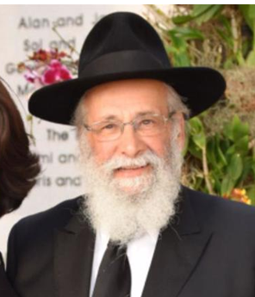
Rabbi Sholom Ber Lipskar

It’s hard to quantify the impact of Rabbi Sholom B. Lipskar, who passed away on Shabbat, May 3 (5 Iyar), at the age of 78.
As the spiritual leader of the Shul of Bal Harbor for more than four decades, he was responsible for converting what was then a Miami neighborhood that was less than friendly to Jews into a flourishing center of Jewish life. And as founder of the Aleph Institute, he is responsible for the Jewish lives of thousands of men and women, both in the armed forces and also in the penal system.
Lipskar was born to Rabbi Eliyahu Akiva and Rochel Lipskar in the Soviet Union, just 20 days before his family’s miraculous escape from the Iron Curtain. Since he lacked any sort of documentation, he made the trip inside a suitcase.

The Family Immigrates to Canada
After several years in DP camps, the family immigrated to Canada where the elder Rabbi Lipskar became an educator.
At the age of 15, Sholom Ber was sent to New York to study at the Central Lubavitcher Yeshivah. In 1969, following his marriage to Chani Minkowicz and a year of advanced study, he and his wife were ready to take their places as emissaries of the Lubavitcher Rebbe, Rabbi Menachem M. Schneerson, of righteous memory. The Rebbe sent them to Miami, which then lacked even the most basic Jewish infrastructure.
Before they departed, the Rebbe told them, “I’m traveling with you! You should go with joy.”
Together, the couple took charge of the fledgling Chabad day school, which had been founded by Rabbi Avrohom Korf.
After a decade in education, the rabbi was ready to broaden his horizons. With the Lubavitcher Rebbe’s encouragement, the couple founded a synagogue in the ritzy Bal Harbour and Surfside area, which was then so opposed to Jewish people living there that the rabbi did not show his face when his wife went house hunting.

A Guiding Light for Other Chabad Centers
From small beginnings, they built up a congregation that has become a guiding light for other Chabad centers to follow. In the early 1990s they built a beautiful center on Collins Avenue known as The Shul, which was then revolutionary in its size and beauty. In fact, it was the Lubavitcher Rebbe himself who described it as a pilot project for the entire world—a place where visitors from across the globe would draw inspiration and bring it back home. Nearly 20 years later, the synagogue had so thoroughly outgrown its existing space that it expanded to the tune of $20 million.
But the rabbi was far from a mere planner and builder of buildings. He was an architect of souls, who has directly brought tens of thousands of individuals and families closer to Judaism. The sheer range of his mentees is astonishing, ranging from wealthy Floridians to down-and-out street people. To him it made no difference. He saw the soul and did what he could to make each one shine that much brighter through exposure to Torah and unfiltered love.
Perhaps no accomplishment defined Rabbi Lipskar more than The Aleph Institute. Founded at the Lubavitcher Rebbe’s urging after a powerful farbrengen call to assist incarcerated Jews, Rabbi Lipskar made it his life’s mission to ensure that no Jew was ever forgotten, no matter how distant. He visited prisons, taught Torah behind bars, and offered dignity and support to countless individuals.

Taking a Group of 20 Jewish Prisoners
to Crown Heights for a Shabbat
Lipskar recalled the time in 1985 when he got permission from the Bureau of Prisons to take a group of 20 screened prisoners from 12 federal facilities to take part in a mentorship program run outside of prison by Aleph. They all traveled to New York, and on Shabbat, Lipskar arranged for the men to join the Lubavitcher Rebbe’s farbrengen at his synagogue at 770 Eastern Parkway in Brooklyn. It being a packed crowd, Lipskar pulled strings to have a table saved for his group so that they could be guaranteed seats together.
At 1:30, just before the farbrengen was set to start, the Lubavitcher Rebbe sent a message to Lipskar via a secretary: The group should not sit together. People would see the prisoners come in together, recognize they did not look like Chassidim and ask them where they came from. This might cause the prisoners embarrassment; instead, the Rebbe said, they should be spread about the room.

The Lubavitcher Rebbe’s Strong
Interest in the Work of Aleph
“There was almost never a time when I passed by the Rebbe for dollars that he didn’t mention Aleph,” Lipskar told Chabad.org in 2019, noting that he would send the Rebbe regular reports on the organization’s activities. “He would give me a dollar especially for Aleph and say, in Yiddish, ‘For the entire Aleph,’ or ‘Aleph [the first letter in the Hebrew alphabet] guides all the letters that follow,’ or something of that nature.”
In time, the organization was expanded to serve people in the armed forces, providing them with kosher food, resources, support and care.
In addition to his wife Chani, he is survived by his children, Devorah Leah Andrusier and Zalman Lipskar, many grandchildren, and his siblings Rabbi Mendel Lipskar, director of Chabad-Lubavitch of South Africa, Batsheva Schochet and Yossi Lipskar.

Reprinted from the website of Chabad.Org

Rav Avigdor Miller on
The Death of Rabbi Akiva

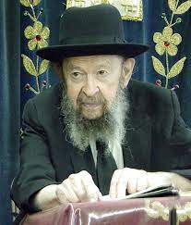
QUESTION: You mentioned before that Rabbi Akiva learned for many years. Why did he deserve such a tragic ending?
ANSWER: Why did such a great tzaddik like Rabi Akiva deserve such a tragic ending?
But you must realize that Rabbi Akiva was 120 years old at that time. He didn’t expect to live much longer. You have to realize also that Rabbi Akiva had fulfilled all of his dreams. He had become the greatest man in the Jewish nation. And if people dream of money – probably he didn’t, but he got it anyhow. He was extremely wealthy. Rabbi Akiva was one of the wealthiest people. He began in poverty – you know a poor boy who becomes a millionaire later, he enjoys it more. And Rabbi Akiva was rolling in money later in life. Rabbi Akiva, his first wife didn’t live 120 years. Then he married a woman who was famed for her beauty, a giyoress. And so, he had everything.
Now, Rabbi Akiva knew that his days were numbered. So, he could die in an old age home where they would diaper him five times a day. It would be a dismal kind of an ending. If you want to die of old age, you have to choose that. You have to make up your mind, that’s it.
So Hakodosh Boruch Hu gave him a gift and he died like a hero. He died with kiddush Hashem. Rabbi Akiva’s death is one of the most beautiful pictures in the history of our nation.
When the Romans said, after the war of Beitar, that it’s forbidden for Jews to teach Torah in public and he went out and taught Torah in public, he knew what it meant. He was arrested. He was kept in prison and finally they put him to the torture and they began combing his flesh off of his bones with ferry combs, like you comb hair of horses. And as they were stripping the flesh off of his bones and he became a bloody mass, Rabbi Akiva was holding himself in and saying kriyas shema. He knew his moments were counted so he was saying kriyas shema. And Rabbi Akiva passed away in the midst of kriyas shema.
Now isn’t that a picture of martyrdom, of kiddush Hashem?
And the Gemara says that at that time, a bas kol came forth and said, “Rabbi Akiva enters Olam Haba immediately.” Other tzaddikim have to go through a little waiting period. Rabbi Akiva immediately entered Olam Haba. And we understand it without the bas kol.
Rabbi Akiva therefore was the most successful man that we would picture, more successful than almost anybody else except Moshe Rabbeinu. Maybe we’ll except also Raban Yochanan ben Zakkai. But Rabbi Akiva in his 120 years achieved the biggest achievements for Torah and his disciples are the ones who handed over everything to us; Rabbi Yehudah and Rabbi Shimon ben Yochai and Rabbi Elazar ben Shamu’a and Rabbi Yosi and Rabbi Meir. They’re the ones from whom we have kol haTorah kulah. And Rabbi Akiva lives forever in the memory of his people as a picture of the man who sacrificed for Torah all his days.
Of course, he also exemplifies the greatness of his wife Rochel because she is the author of all his greatness.
And so, Rabbi Akiva is the picture of a man who gave his life for kiddush Hashem. So, what could be more fortunate than that instead of dying miserably of disease and old age?

Reprinted from a recent email of Toras Avigdor based on a Thursday night lecture delivered on February 4, 1982.

******************************************************************
Therefore, shall you keep my commandments, and do them ("otam"); I am the L-rd (22:31) The letters of "otam" can be rearranged to form the word "emet," truth. From this we learn the importance of approaching mitzvot truthfully, and not being deceived into thinking we have an unlimited amount of time to do them, as it states in Ethics of the Fathers:
"Do not say, 'When I will have free time I will study.'" Rather, we should be aware that time is short, and "collect" as many mitzvot as possible in this world. (Mipi Hashemua)

Reprinted from the Parshat Emor 5785 email of R’ Yedidya Hirtenfeld’s whY I Matter parsha sheet for the Young Israel of Midwood in Brooklyn.

The Connection of Counting Sefirat Ha’Omer and the Coming of Moshiach
From the Teachings of the Lubavitcher Rebbe
Rabbi Menachem Mendel Schneerson, Zt”l

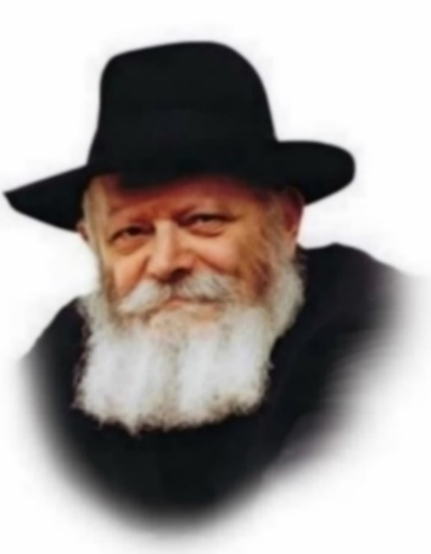

This week's Torah portion, Emor, contains the mitzva of Sefirat Ha'omer, the commandment to count the 49 days between Passover and Shavuot: "And you shall count from the next day after the Sabbath...seven Sabbaths shall be complete."
As with any other mitzva, counting the omer requires a blessing. Each day of the Sefira period we recite the blessing, then count how many days (and weeks) have elapsed.
But what happens if we've forgotten to count? According to one opinion, each day of counting is a mitzva in its own right. If one day we forget to count, it doesn't affect the coming days and we may continue. According to another opinion, the entire 49-day period is a single mitzva. If we forget to count one day, the mitzva has been compromised, and we may not continue. Jewish law establishes, however, that even if we miss a day we should continue counting, albeit without a blessing.
A person who converts to Judaism during Sefira was obviously unable to perform the mitzva before he became Jewish. Starting from the day he converts he is obligated to count; nonetheless, he cannot truthfully say, "Today is the third day" (or whichever day it is), being that he has not counted the previous days.
A child who becomes Bar or Bat Mitzva during Sefira is obligated by the Torah to count, even though the counting began before he attained majority. He is even permitted to continue reciting the blessing, as his performance of the mitzva before Bar Mitzva was for educational purposes. (However, while still a minor, his counting was only obligatory by Rabbinic law.)
There are some halachic authorities who opine that at present, until Moshiach comes, the entire mitzva of Sefirat Ha'omer is only Rabbinic. If Moshiach comes during Sefira (may it happen immediately), we will continue counting and reciting the blessing, once again obligated by Torah law.
Our Sages teach that the mitzvot we observe during the exile are only in preparation for the mitzvot we will perform in the Messianic Era. As we say in our prayers, "There we will offer to You our obligatory sacrifices...in accordance with the command of Your will." In other words, when the Holy Temple will be rebuilt, our mitzvot will be "in accordance with the command of Your will"; in the meantime, they are not the ultimate objective, but a preparation for and semblance of the future.
Nonetheless, the mitzvot we do now are still precious, as they are the channel through which we will eventually perform them after the Final Redemption. Moreover, Sefirat Ha'omer is particularly important. In the merit of this mitzva, may we continue to count Sefira with Moshiach's arrival.

Reprinted from the Acharei Mos-Kedoshim 5762/2002 edition of L’Chaim. Adapted from Volume 1 of Likutei Sichot.

******************************************************************

For any man in whom there is a blemish shall not approach (21:18) When Rabbi Jacob was appointed chief rabbinical authority of the city of Lissa he had many opponents.
One day he approached their leader and asked him why he objected. "Do you think I am not enough of a scholar? Are you dissatisfied with my qualifications?" "Oh, no," the man replied, "it's just that you are too young. It doesn't look nice to have a person your age as our head."
"In that case," the Rabbi replied, "you needn't worry. I promise you that it is a 'temporary blemish,' and that with every passing day it will lessen..." (Mei'otzareinu Hayashan)

Reprinted from the Parshat Emor 5785 email of R’ Yedidya Hirtenfeld’s whY I Matter parsha sheet for the Young Israel of Midwood in Brooklyn.

Rabbi Berel Wein on
Parshat Emor 5785

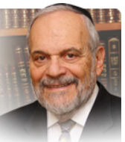

The review of the yearly holidays of Israel appears in this week’s parsha. This type of review also appears in a number of different places in the holy Torah. The reasons advanced by the commentators for this seemingly unnecessary repetition are many, varied and insightful. But there is one that truly resonates with me and I think it has great relevance to our times and circumstances. And the gist of this explanation, of the necessity for repeating the holiday cycle a number of times, is as follows: The original mention of the holiday cycle is directed to a generation that seemingly needed no such reminders or instructions.

The holiday of Pesach and the commemoration of the exodus from Egyptian bondage were fresh in the minds and memories of the generation of the desert.
And the holiday of Succot was a daily event in their lives, living as they did in their tents and underneath the heavenly clouds in the desert of Sinai. The agricultural nature of Succot - the ingathering of the summer produce of the land – and of Shavuot – the harvest of the spring and winter grain crop and the offering of the first fruits of the land in the Temple – were not yet relevant to that generation, a generation that would not live to see the Land of Israel inhabited by the people of Israel. That description of the holiday cycle came to teach Israel that this cycle was eternal, independent of geographic reality, and not subject to the actual circumstances of life and locality then present in the Jewish world.

The further repetitions of the holiday cycle dealt with the service of the sacrifices to be offered in the Temple. This repetition is Temple service oriented. In the absence of the Temple and its sacrificial service and of the loss of the Jewish homeland and its agricultural produce, one would have possibly thought that the holidays no longer had true meaning, and in effect could stop to exist. This is what happened to other faiths, cultures and even mighty empires. The loss of power, homeland and sovereignty also made their holidays and days of historical and national commemoration extinct. The Jewish people, faith and its Torah have survived for millennia without nationhood, homeland and with the absence of any vestige of temporal power. One of the main reasons for this near miraculous ability to survive and even thrive has been the proper halachic observances of the holidays of the Jewish calendar year.

There is almost an unconditional and unconnected review of the holidays again in the book of Dvarim, for the observance and importance of the holidays is never relegated to particular generations or geographic locations. The holidays denote the passage of time on the Jewish calendar but they themselves are timeless and, in a certain sense, they are above purely historical time. The very repetitions of the holidays that appear in the Torah serve to remind us of this fact, of our spiritual existence. As a consequence of our return to our ancient homeland, the agricultural nature of the holidays now exists once more. It confirms the timeless quality that the holidays of the Jewish year represent.

Shabat shalom.
Reprinted from the current website of rabbiwein.com

******************************************************************
And out of the sanctuary he shall not go (21:12) A Jew's thoughts must always be of holy matters, connected to G-dliness and sanctity, even when engaged in seemingly mundane affairs. At such times (such as when conducting necessary business), the Jew should consider himself as having left his "home" temporarily, with the intention to later return. The warm influence of the home will carry over also when he is in the street. (Baal Shem Tov)

Whosoever of your seed in their generations shall have a blemish shall not approach to offer the bread of his G-d (21:17) The specific defects that invalidate a kohen from performing the priestly service are physical manifestations of a spiritual defect. G-d, in His infinite wisdom, knows precisely which souls are worthy of offering sacrifices and those that are not. (Sefarim)

Reprinted from the Parshat Emor 5785 email of R’ Yedidya Hirtenfeld’s whY I Matter parsha sheet for the Young Israel of Midwood in Brooklyn.
The Obstetrician Who Has Delivered More than
18,000 Babies and Counting
By Daniel Keren

Dr. Jessica Jacob
Dr. Jessica Jacob, an obstetrician who graduated New York University in 1983 and has been operating a solo practice since 1987 was recently interviewed about her unique devotion to delivering babies by Charlene Aminoff, hostess of Not Your Typical Podcast from the Living L’Chaim network. Mrs. Aminoff’s enthusiasm was fueled in part by the fact that Dr. Jacob has delivered all of her children and as one of the few Orthodox Jewish women delivering babies, brings a unique spiritual perspective to her job or mission in life.
In addition to delivering babies for thousands of women, Dr. Jacob herself gave birth of seven children and is today the grandmother of more than 25 children. Today she is affiliated with the North Shore University Hospital, part of Northwell Health in Manhasset, Long Island.
In the interview, Mrs. Aminoff asked Dr. Jacob about her strong desire to help women get natural vaginal deliveries of their babies as opposed to having C-Section births. Dr. Jacob emphasized how important it is for a woman to have nature vaginal births for their children as it makes future deliveries safer and less painful. And her commitment is despite the fact that insurance companies pay doctors significantly more for C-Section deliveries than they do for more natural and healthier vaginal deliveries.
One of the pointers that Dr. Jacob mentioned in her interview with Mrs. Aminoff was that she warns her patients to seriously understand just how important it is to control their weight as being that this is a very important role in ensuring a healthy delivery.
Dr. Jacob also told listeners of the Not Your Typical Podcast is if a woman is going to give birth, she should make sure that the obstetrician she is thinking of using has good reviews. One should not just use an obstetrician because he or she is the only one that accepts your insurance. It is better to pay without insurance and have a good doctor to deliver one’s baby. Dr. Jacob says that when she has such a patient, she charges significantly below the fee that she would have gotten from the insurance company.
Mrs. Aminoff asked Dr. Jacob what she is really concerned about and she mentioned that she is fiercely opposed to the current trend of some women wanting to have “more natural” births by having their babies delivered at homes by special doctors. Dr. Jacob explained that there are many potential dangers that can occur and if one is in a hospital, these can be more easily alleviated and she hopes that rabbis will come out and strongly prohibit the planned giving birth at home.
Her dedication to delivering babies comes with a price. Dr. Jacob says that she isn’t able to go on vacations. Indeed, she has gone on three 12-hour trips to Israel, without ever having to stay overnight in a hotel. Two of those trips were for chasanas and the third trip was to make a shiva call. Indeed, she has even rushed to the hospital from the wedding of one of her childrem while dressed in her clothes and fancy wig in order to help one of her patients give birth.
When asked by Mrs. Aminoff as to Dr. Jacob’s definition of success, she said that it is a life that gives her happiness, satisfaction and a sense of having done something important. And what can be more important than bringing new Jewish neshamos into this world?
Dr. Jacob has had the delightful privilege of delivering the children of babies that she had delivered a generation before. One poignant moment was when she delivered a baby from a couple – the father and the mother – whom she had delivered on separate occasions.
To view or listen to this 57-minute podcast you can google She Delivered 18,000 Babies But Few Know the Full Story

Reprinted from the May 9, 2025 edition of The Jewish Connection.

Thoughts that Count for Our Parsha

They shall not make any part of their head bald, nor shall they shave off the corner of their beard, nor make any gashes in their flesh... They shall be holy to their G-d (Lev. 21:5-6)
In ancient times it was the custom of idolatrous priests to alter their appearance, as a symbol of their status. Without these external markings their distinction would not be apparent, and everyone would know that they engaged in the same abominations as their fellow idol worshippers. By contrast (as if a comparison may be drawn!), kohanim (the descendants of Aaron) do not need any external signs of their exalted holiness. They are already holy, and are recognizable by their good deeds. (Maharil Diskin)

For any man in whom there is a blemish shall not approach (Lev. 21:18)
When Rabbi Jacob was appointed chief rabbinical authority of the city of Lissa he had many opponents. One day he approached their leader and asked him why he objected. "Do you think I am not enough of a scholar? Are you dissatisfied with my qualifications?" "Oh, no," the man replied, "it's just that you are too young. It doesn't look nice to have a person your age as our head." "In that case," the Rabbi replied, "you needn't worry. I promise you that it is a 'temporary blemish,' and that with every passing day it will lessen..." (Mei'otzareinu Hayashan)

Therefore, shall you keep my commandments, and do them ("otam"); I am the L-rd (Lev. 22:31)
The letters of "otam" can be rearranged to form the word "emet," truth. From this we learn the importance of approaching mitzvot (commandments) truthfully, and not being deceived into thinking we have an unlimited amount of time to do them, as it states in Ethics of the Fathers: "Do not say, 'When I will have free time I will study.' " Rather, we should be aware that time is short, and "collect" as many mitzvot as possible in this world. (Mipi HaShemua)

You shall not defile ("techal'lelu") My holy Name; and I shall be sanctified among the Children of Israel (Lev. 22:32)
According to the Zohar, the root of the Hebrew word for defilement is "chalal," meaning an empty space. G-d's holy Name becomes defiled if we act as if the place we is standing on is devoid of Him. (Nefesh HaChaim)

Reprinted from the Acharei Mos-Kedoshim 5762/2002 edition of L’Chaim

Between Borders:
Navigating My Identity as
An Asian-Canadian Jew
By Hannah Geithner

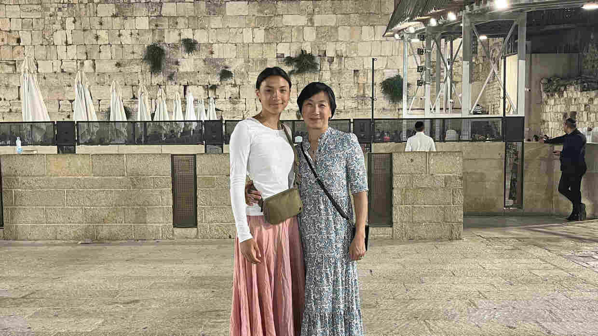

Growing up and discovering who we are often comes with the discomfort of not fitting into our own ideas of “normal.” As a child, I struggled to reconcile the different aspects of my identity. Now, nearing my seventeenth birthday, I still grapple with balancing my love for Canada, my Jewish soul, and my mixed heritage.
My mother, who was born in Seoul and grew up in Alberta during the 1970s and 80s, experienced racism that no child should have to endure. I grew up in a more accepting Canada. Born in Canada, I spent four years in Taiwan when my parents were posted there as diplomats.
Back in Ottawa, the national anthem is played every morning at my high school, and every July 1st my family celebrates Canada Day. When my father recounts stories of his childhood in apartheid South Africa, I feel beyond grateful to have been given the gift of being born into this wealthy, stable and multicultural country. I take equal pride in being Canadian and Jewish.
Despite the presence of many Jews of color in North America, I often felt alienated as an Asian Jew, my mother having converted. At sleepaway camp, I was called “Sushi” behind my back and asked if I could speak Chinese.
As I got older, people questioned if I was really Jewish because I didn’t look Ashkenazi. I grew tired of explaining my background and ‘proving’ my religiosity. I hated the looks of surprise people gave me when I told them that I observed Shabbat and kept kosher.
Being treated as different in my own community hurts. But as much as it could feel isolating, the Jewish community has held me close in every other aspect. It has given me the morals and guidance to live my life in a way that keeps me close to G-d and the people around me. It has taught me to try and make the world a better place through acts of kindness and giving charity. I have felt at home in every shul, from Bali to Jerusalem.
In Taiwan and Ottawa, I was never the only mixed kid in my class but always the only observant Jew, the only one missing seemingly countless days of school for Jewish holidays and not getting to attend birthday parties because they were held on a Saturday (Shabbat). Early on, classmates were curious about my heritage; no one questioned my Hanukkah presentations.

Effects of Increasing Antisemitism
But that changed in middle school. Suddenly, everyone had an opinion about “The Jews” and was an expert on the geopolitics of the Middle East. In 2021, as Hamas launched missiles, my Instagram feed exploded too. Students in my grade felt the need to advocate for Palestine, although the majority of them had never even heard of the conflict, let alone be able to place it on a map.
I used to be able to turn off antisemitism by shutting my phone. But just a couple of years later that easy fix no longer worked.
When Hamas attacked Israel on October 7th, there was nothing that could stop the collective pain and panic that ensued in my community. The horrific violence that the terrorist organization inflicted on thousands of civilians, murdering, torturing, raping and taking hostages from their own homes and at the Nova festival left us all broken. Our calls and texts felt futile; we were powerless in the diaspora. Fear and anger took over that first week. As always, our community united to raise funds and send supplies.
Nonetheless, we felt abandoned by our government that claimed it stood with the Jewish-Canadian community, even as our institutions were vandalized and communities threatened without serious repercussions. I felt as though the only people we could count on were fellow Jews and a handful of courageous gentile friends and neighbors.
That fall, the mezuzah, placed on Jewish doorposts as a sign of identity and faith, was stolen off the front door of our house, and my synagogue in Ottawa received numerous threats (none of which thankfully came to fruition).
All of a sudden, the whispers of the end of the golden age of North American Jewry felt very real. At school, my classmates were back to posting things like “support Palestine if you’re human,” and shushing me for saying that women being sexually assaulted on October 7th was wrong. There are too many similar instances to count.
Finally, after losing “friends” and shedding many tears, I came to peace with our predicament: somehow, being Canadian and a Jew who supports the state of Israel is not socially acceptable, at least not amongst the TikTok generation.
That did not mean that I became silent – quite the opposite, actually. In April of 2024, I became part of the Kenneth Leventhal High School Internship, an Israel advocacy and antisemitism education program run by StandWithUs. Through this program, I found strength in peers facing similar struggles.
Though my background adds complexity, I am, above all, a proud Jew. No pressure will ever silence me. Am Yisrael Chai!

Reprinted from the current website of aish.com

******************************************************************
You shall sanctify him (the Kohain), for he offers the food of your G-d. (21 6) The second pasuk is describing the Mitzvah of sanctifying a Kohain. One must treat the Kohain with respect - honor him - he goes first etc. But this obligation upon Benai Yisroel only comes after the first pasuk.
First the Kohain must be holy to Hashem. The kohain must first sanctify himself with his own actions. Only then is there an obligation for Benai Yisroel to treat him with Kedusha. (Oznayim LaTorah)

Reprinted from the Parshat Emor 5785 email of R’ Yedidya Hirtenfeld’s whY I Matter parsha sheet for the Young Israel of Midwood in Brooklyn.

